**Water wheel survey OCR test**

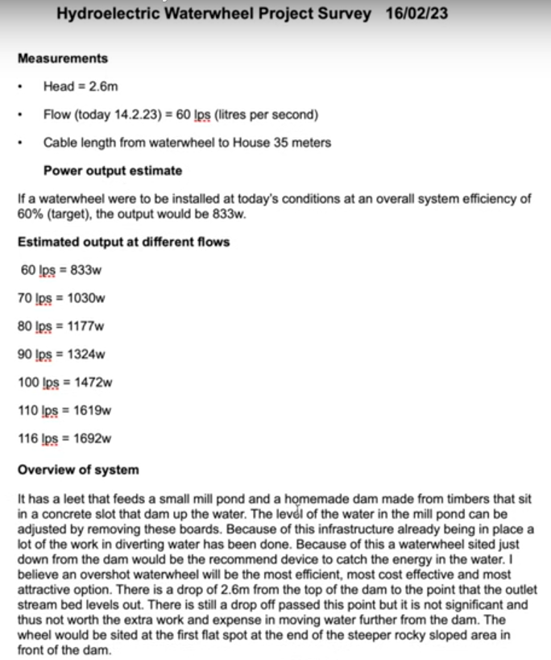

**Hydroelectric Waterwheel Project Survey 16/02/23**

**Measurements**

• Head = 2.6m

Flow (today 14.2.23)= 60 lps (litres per second)

Cable length from waterwheel to House 35 meters

**Power output estimate**

If a waterwheel were to be installed at today's conditions at an overall system efficiency of 60% (target), the output would be 833w.

**Estimated output at different flows**

**60 lps = 833w**

**70 lps = 1030w**

80 lps = 1177w

90 !ps = 1324w

100 lps = 1472w

110 lps = 1619w

116 lps = 1692w

**Overview of system**

It has a leet that feeds a small mill pond and a homemade dam made from timbers that sit in a concrete slot that dam up the water. The level of the water in the mill pond can be adjusted by removing these boards. Because of this infrastructure already being in place a lot of the work in diverting water has been done. Because of this a waterwheel sited just down from the dam would be the recommend device to catch the energy in the water. I believe an overshot waterwheel will be the most efficient, most cost effective and most attractive option. There is a drop of 2.6m from the top of the dam to the point that the outlet stream bed levels out. There is still a drop off passed this point but it is not significant and thus not worth the extra work and expense in moving water further from the dam. The wheel would be sited at the first flat spot at the end of the steeper rocky sloped area in front of the dam.

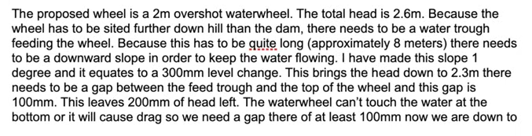

The proposed wheel is a 2m overshot waterwheel. The total head is 2.6m. Because the wheel has to be sited further down hill than the dam, there needs to be a water trough feeding the wheel. Because this has to be quite long (approximately 8 meters) there needs to be a downward slope in order to keep the water flowing. I have made this slope 1 degree and it equates to a 300mm level change. This brings the head down to 2.3m there needs to be a gap between the feed trough and the top of the wheel and this gap is 100mm. This leaves 200mm of head left. The waterwheel can't touch the water at the bottom or it will cause drag so we need a gap there of at least 100mm now we are down to

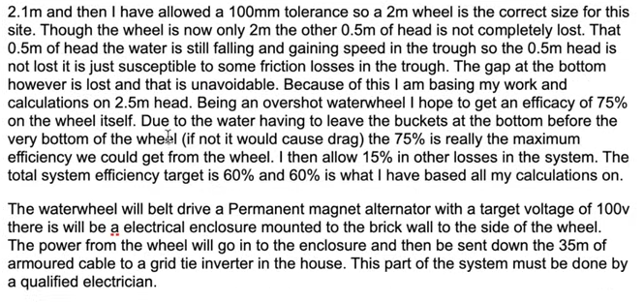

2.1m and then I have allowed a 100mm tolerance so a 2m wheel is the correct size for this site. Though the wheel is now only 2m the other 0.5m of head is not completely lost. That 0.5m of head the water is still falling and gaining speed in the trough so the 0.5m head is not lost it is just susceptible to some friction losses in the trough. The gap at the bottom however is lost and that is unavoidable. Because of this I am basing my work and calculations on 2.5m head. Being an overshot waterwheel I hope to get an efficacy of 75% on the wheel itself. Due to the water having to leave the buckets at the bottom before the very bottom of the wheel (if not it would cause drag) the 75% is really the maximum efficiency we could get from the wheel. I then allow 15% in other losses in the system. The total system efficiency target is 60% and 60% is what I have based all my calculations on.

The waterwheel will belt drive a Permanent magnet alternator with a target voltage of 100v there is will be a electrical enclosure mounted to the brick wall to the side of the wheel. The power from the wheel will go in to the enclosure and then be sent down the 35m of armoured cable to a grid tie inverter in the house. This part of the system must be done by a qualified electrician.

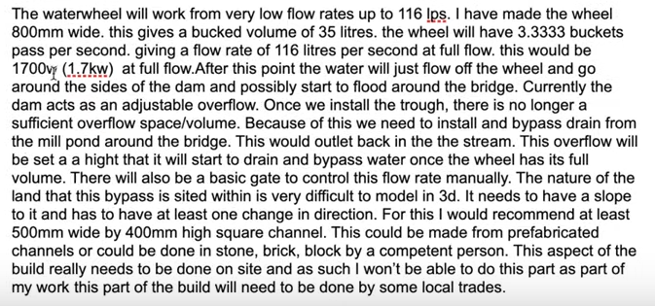

The waterwheel will work from very low flow rates up to 116 Ips. I have made the wheel 800mm wide. this gives a bucked volume of 35 litres. the wheel will have 3.3333 buckets pass per second. giving a flow rate of 116 litres per second at full flow. this would be 1700v (1.7kw) at full flow. After this point the water will just flow off the wheel and go around the sides of the dam and possibly start to flood around the bridge. Currently the dam acts as an adjustable overflow. Once we install the trough, there is no longer a sufficient overflow space/volume. Because of this we need to install and bypass drain from the mill pond around the bridge. This would outlet back in the the stream. This overflow will be set a a hight that it will start to drain and bypass water once the wheel has its full volume. There will also be a basic gate to control this flow rate manually. The nature of the land that this bypass is sited within is very difficult to model in 3d. It needs to have a slope to it and has to have at least one change in direction. For this I would recommend at least 500mm wide by 400mm high square channel. This could be made from prefabricated channels or could be done in stone, brick, block by a competent person. This aspect of the build really needs to be done on site and as such I won't be able to do this part as part of my work this part of the build will need to be done by some local trades.

